
Company
Logotype

Cone Beam Computed Tomography- Report



Porur Dental X-rays & CBCT

Patient Name : Mrs. Latha Patel | Date of Report : 21.06.2024
Age/ Gender : 63 years/ Female | Region of Interest : CBCT Full Skull
Referring doctor: Dr. M. Balamurali Sai | Indication : To rule out periapical pathology
Clinical Notes: Nil
PATIENT INFORMATION

CBCT- Maxilla provided
CBCT – IMAGE DETAILS

RADIOGRAPHIC INTERPRETATION

- Completely missing crown and root portion in relation to 17, 18, 26, 27, 28, 38, 48.
- Presence of hyperdense crown structures in relation to 14, 15, 16, 36.
- Dental caried in mesio proximal region: 48
- Dental caries in disto proximal region and crown: 35, 44
- Buccally placed: 45
- In relation to the periapical aspect of 47, presence of a diffuse irregular hyperdense region, in contact with the apical third of 47 is present.
- The right and left maxillary sinus is present with mucosal thickening in the medial wall and floor.

RADIOGRAPHIC IMPRESSION

- Crowns in relation to 14, 15, 16, 36.
- Dental caries: 35, 44, 45.
- Partially edentulous Maxillary and Mandibular arch.
- Idiopathic osteosclerosis: 47 region
- Bilateral Maxillary sinusitis.

Kindly correlate with clinical findings


IMAGES FOR REFERENCE

RECONSTRUCTED PANORAMIC VIEW

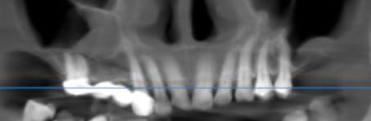

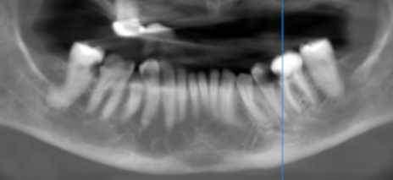

CORONAL VIEW – showing the maxillary sinus mucosal thickening

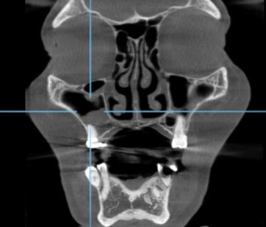

CROSS SECTIONAL VIEW – showing the diffuse periapical hyperdense region in 47 region
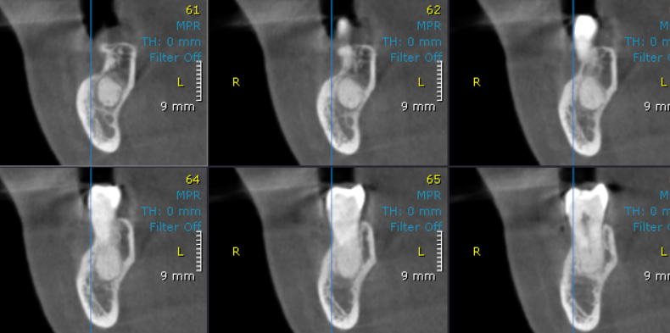

3-DIMENSIONAL VIEW

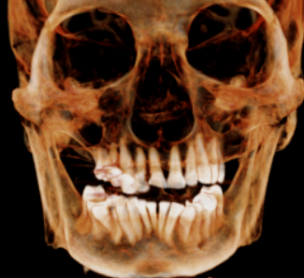

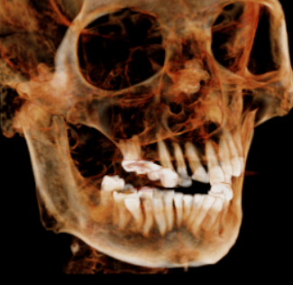
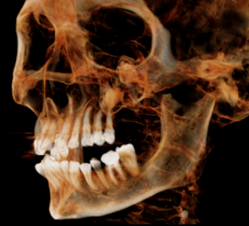

**** End of report ****

